## Case study: adsorption kinetics

Ovalbumin, a protein from chicken egg white, adsorbs spontaneously on the air/water interface due to hydrophobic interactions [3]. Interfacial adsorption kinetics and their underlying mechanisms are crucial to the stability of colloidal systems. However, they are poorly understood and difficult to measure. Drension is a useful tool to study these interfacial phenomena.

In order to follow the adsorption kinetics of albumin, we propose the following model based on the Cassie-Baxter theory:



where 𝛾(0) is the surface tension of a droplet without protein and 𝛾(∞) is the surface tension of a water-air interface packed at equilibrium. As the adsorption is assumed to be diffusion-controlled, we pose

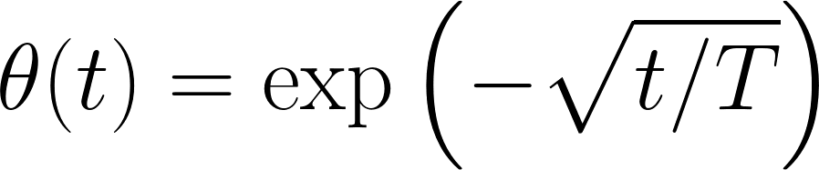

with $T=\frac{πΓ_{f}^{2}}{4Dc^{2}}$ where D denotes the diffusion coefficient (m2/s) ,c the bulk concentration (m-3) and a Langmuir parameter (m-2) [5]. From figure 4, it becomes evident that the adsorption dynamics observed by Drension are described reasonably well by our proposed diffusion-limited adsorption model.

## Methodology

The shape of a pendant drop depends on the Bond number (Bo), which is a number describing the balance between the Laplace pressure and gravity.

FORMULA

The surface tension of a droplet can be calculated from the drop radius R0 at the apex and Bond number associated with the droplet. Both the size and the bond number of the droplet can be calculated using pendant drop tensiometry. The size can easily be found by comparing the droplet to an object of known size (in our case the needle) and the bond number can be determined by fitting the droplet profile with the Young-Laplace equation. This fitting process is shown in Figure 3. The accuracy of the measurement can be determined by averaging. With Drension, a very reasonable estimate for the surface tension of water was found after only 1.5 seconds (Figure 1).